INTRODUCTION :

**1.Overview:**

A business estimate is a document that provides potential clients with an approximation of the costs associated with the goods or services they are interested in. It is important to remember that an estimate is not a binding contract, but rather a tool used to help secure business.

This involves estimating all the expenses required to start and operate the business, such as equipment, rent, inventory, and marketing. By calculating these costs upfront, business owners can better plan their budget and avoid unexpected expenses.

The most common way to categorize them is into operating vs. non-operating and fixed vs. variable.

The nature-of expense classification refers to the expenses that are recorded or disclosed on the basis of the nature of the categories they are spent on. Such expenses include raw materials, depreciation, transports, and staffing costs.

marketing expense is the amount of money spent in promoting, advertising, or marketing a business and its products, services, or solutions. These expenses are costs that directly contribute to the performance of marketing activities and overall efforts.

An expenditure is a payment of cash or credit for goods or services, often by a business, organization or corporation. The purchase may be to obtain new assets, improve upon or repair assets, or reduce liability.

**1.2 Purpose**

Tracking business expenses helps you understand your business's cash flow. Business owners can more easily understand cash flow – an essential business survival factor – when they accurately track expenses. “One of the primary reasons why most businesses fail is the mismanagement of the cash flows,” Holmes warned.

***Efficiency analysis***:

Expenditure analysis involves processing a small amount of relevant procurement data in order to learn from it and thereby improve operations. It should be carried out in the context of a clear, shared procurement strategy

***Supply and demand analysis***:

Supply and demand analysis tool

Analyze your external business environment.

Evaluate the evolution of your market and consumer habits.

Brainstorm the forces affecting your company.

Assess the strengths and weaknesses of the competition.

Make decisions about your offer, your prices, your supply chain and your margins

Supply and demand is an economic model that provides the basis for the consumer economy. The given supply and cost of a good is driven by demand and how much consumers will pay for the good. When demand for a good is high, the price increases, and when the demand is low, the price drops in response

We can achieve more customers and improve income using ideas Problem Definition & Design thinking

**2.2 Empathy Map and Brain storming**

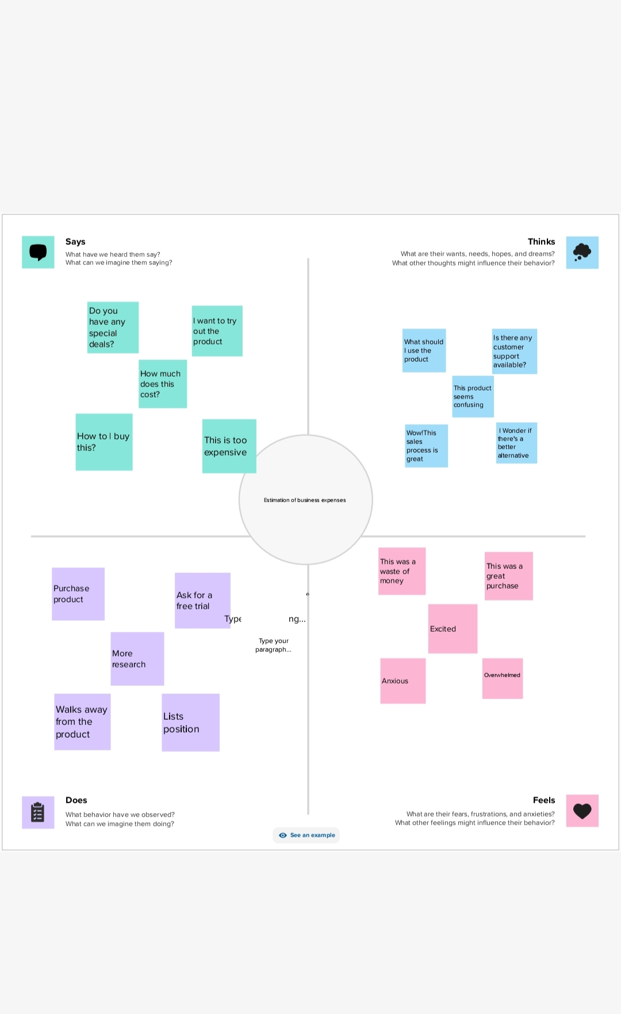

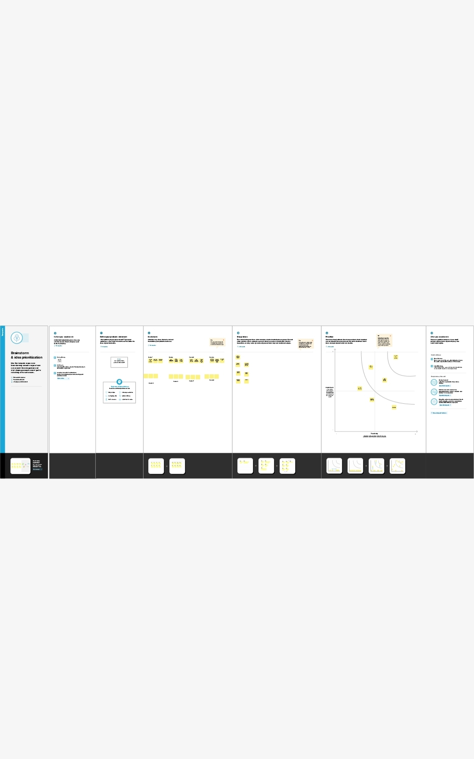

SHEET 1:

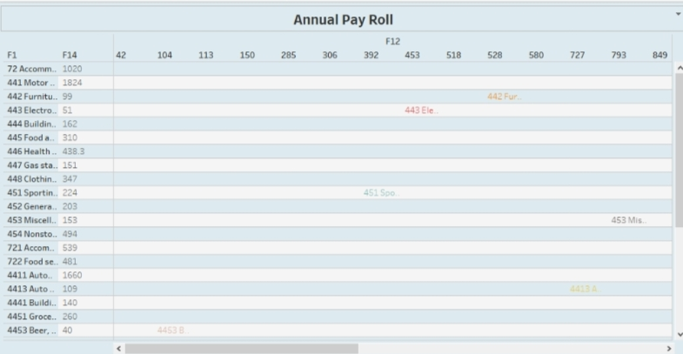

SHEET 2:

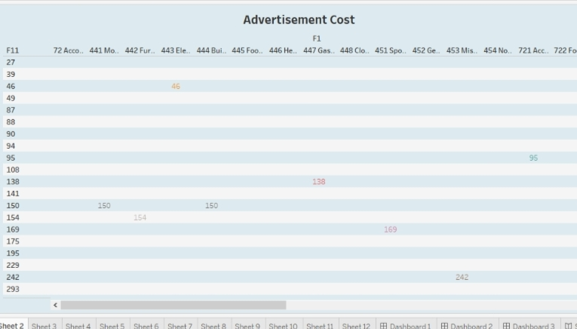

SHEET 3:

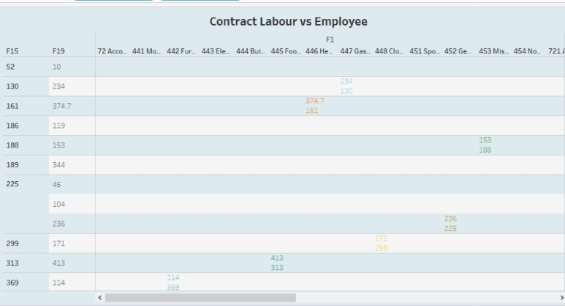

SHEET 4:

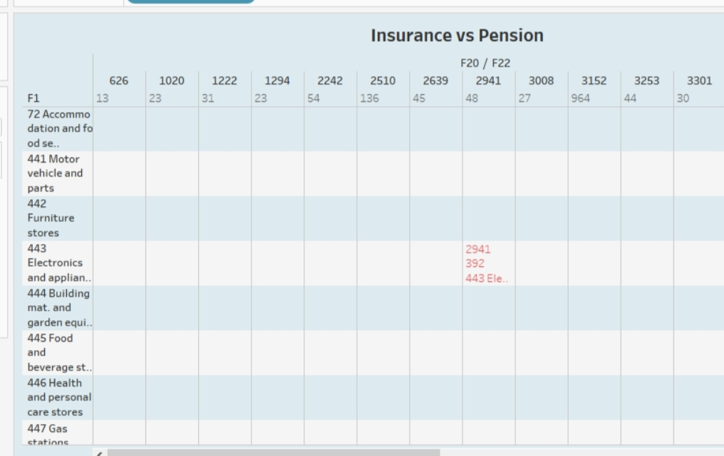

SHEET 5:

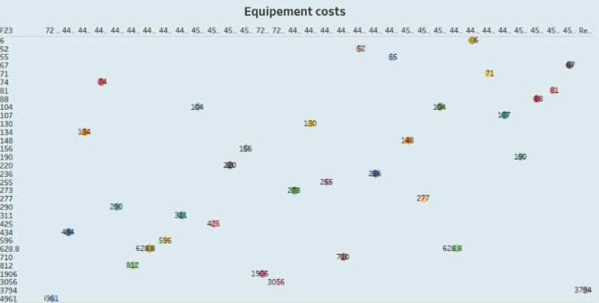

SHEET 6:

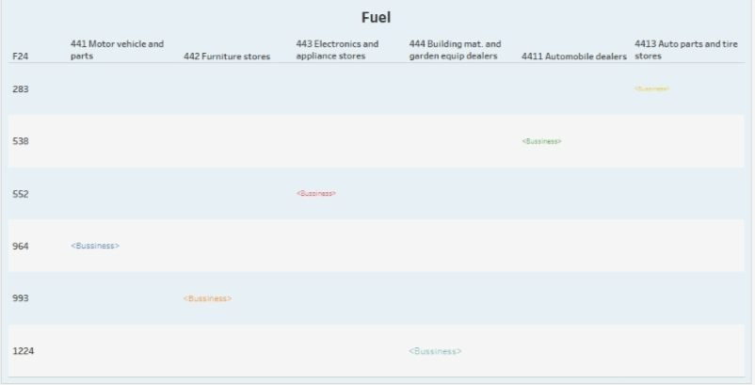

SHEET 7:

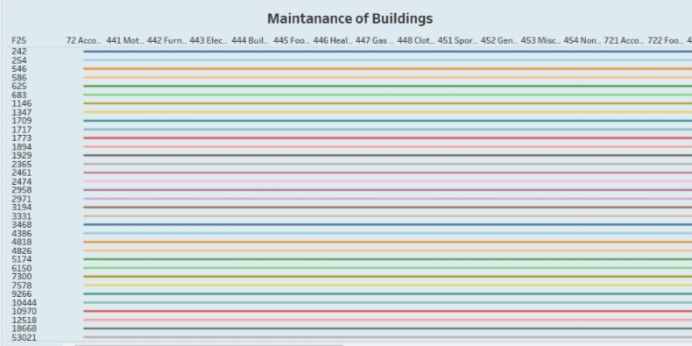

SHEET 8:

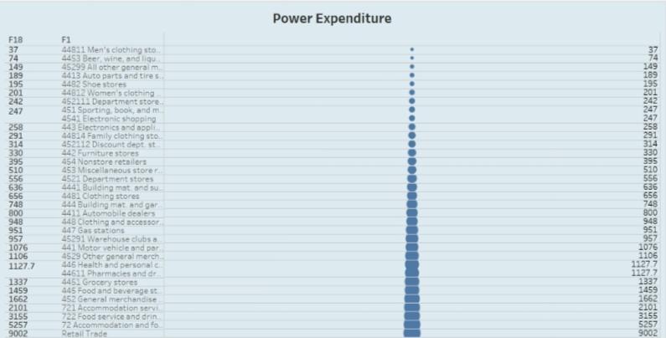

SHEET 9:

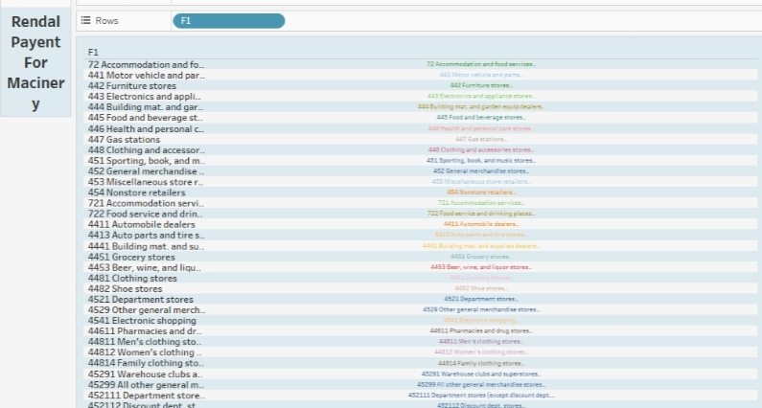

SHEET 10:

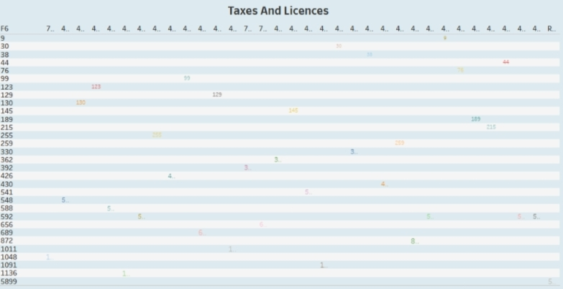

SHEET 11:

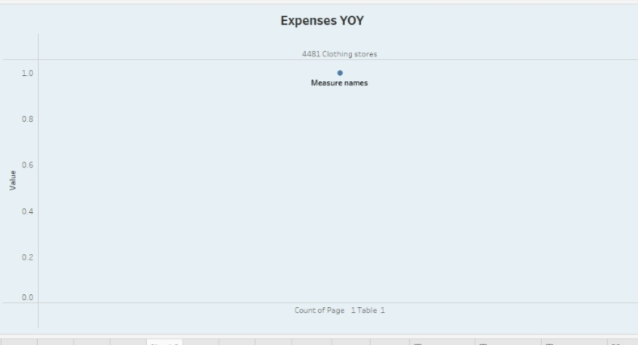

SHEET 12:

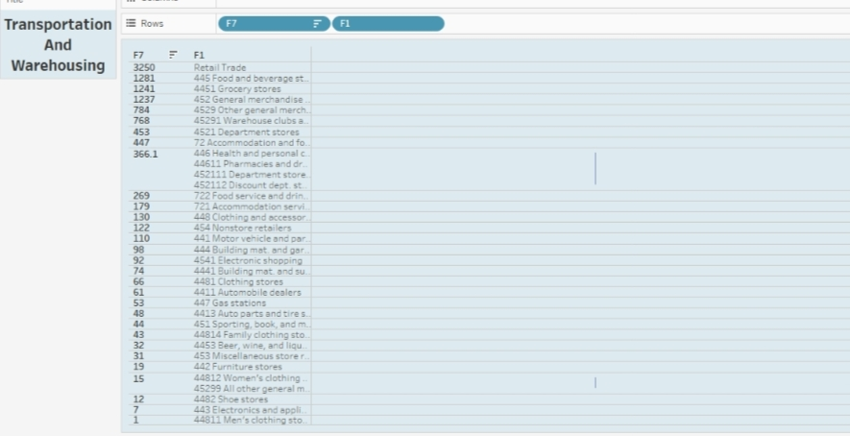

Advantages and disadvantages:

**DISADVANTAGES:**

Financial Risks. A business requires an extensive amount of financial resources to launch and expand. ...

Time Commitment. ...

Dealing with Stress. ...

Risk of Failure. ...

High Competition. ...

Possible Lack of Guidance. ...

Lack of Business Processes and Operational Procedures

**ADVANTAGES**:

It helps you to identify future cash flow issues

It helps you better understand your competition

helps you to allocate resources

Creative Freedom, Person Expenses are deducted from revenue to arrive at profits. Businesses are allowed to deduct certain expenses from taxes to help alleviate the tax burden and bulk up profits.

**APPLICATIONS:**

Expenses are deducted from revenue to arrive at profits. Businesses are allowed to deduct certain expenses from taxes to help alleviate the tax burden and bulk up profits.

Examples of expenses include rent, utilities, wages, salaries, maintenance, depreciation, insurance, and the cost of goods sold. Expenses are usually recurring payments needed to operate a business.

**CONCLUSIONS:**

In conclusion, cost estimation is an important component of project management that ensures projects are finished on schedule and within budget. Since inaccurate cost estimates can have serious financial consequences for businesses, accurate cost estimating is crucial for all stakeholders engaged in a project.

formula for calculating expenses in a business is: Total Expenses = Cost of Goods Sold (COGS) + Operating Expenses. Vakilsearch can assist you in understanding the legal and regulatory requirements related to business expenses, ensuring compliance and smooth operations.

Improve the accuracy of cost, schedule, and resource estimates

Define a baseline for performance measurement and control

Facilitate clear responsibility assignments

**FUTURE SCOPE:**

Is predicted that businesses that are based on collaborative economy models will enjoy immense success in the next few years. Some good examples are Airbnb, Uber, Ola and Lyft. These types of businesses not only help the final customers, but also assist the service providers and ultimately make commissions